# IMPLEMENT WORD COUNT/FREQUENCY PROGRAMS USING MAPREDUCE

**AIM:**

To implement the python mapper and reducer programs using MapReduce to count the words in a text file using Hadoop.

# PROCEDURE:

1. Open command prompt and run as administrator and start the Hadoop by using the command:

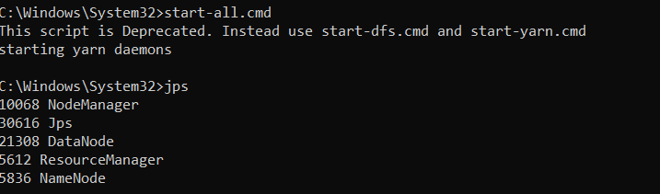

1. Create a new directory in the Hadoop file systems using the command: 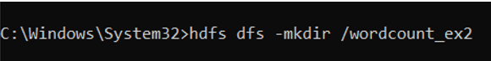
2. Upload the input text file into the wordcount_ex2 directory using the command:



1. Create the mapper and reducer files.
2. To execute the files with Hadoop streaming run the following command:

C:\Windows\System32>hadoop jar "C:\hadoop\share\hadoop\tools\lib\hadoop-streaming-3.3.6.jar" ^-input /wordcount_ex2/word.txt ^-output /wordcount_op ^-mapper "python C:/hadoop_wordcount/mapper.py" ^-reducer "python C:/hadoop_wordcount/reducer.py"

# MAPPER.PY

#!/usr/bin/env python

import sys

# Read lines from standard input

for line in sys.stdin:

# Strip leading and trailing whitespaces

line = line.strip()

# Split the line into words

words = line.split()

# Output each word with a count of 1

for word in words:

print(f'{word}\t1')

**REDUCER.PY**

#!/usr/bin/env python

import sys

from collections import defaultdict

# Initialize a dictionary to store word counts

word_count = defaultdict(int)

# Read lines from standard input

for line in sys.stdin:

# Strip leading and trailing whitespaces

line = line.strip()

# Split the line into word and count

word, count = line.split('\t', 1)

try:

count = int(count)

except ValueError:

# If count is not an integer, skip this line

continue

# Add the count to the word's total

word_count[word] += count

# Output each word and its total count

for word, count in word_count.items():

print(f'{word}\t{count}')

# OUTPUT:

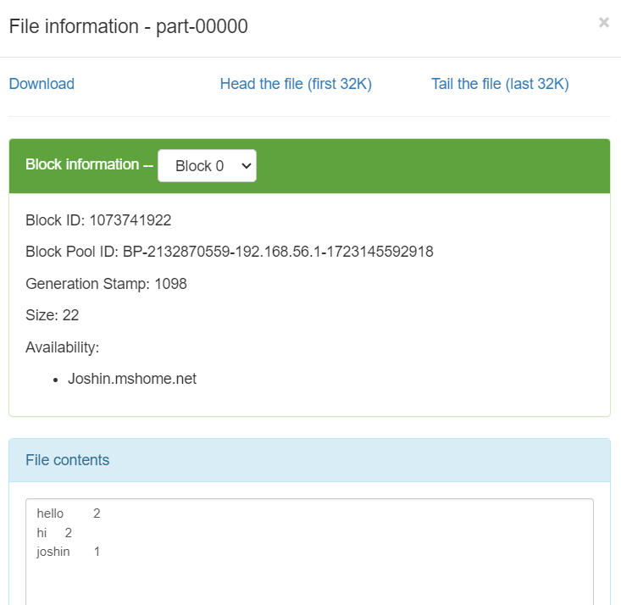

**RESULT:**

Thus the implementation of the python mapper and reducer programs using MapReduce to count the words in a text file using Hadoop is executed successfully.